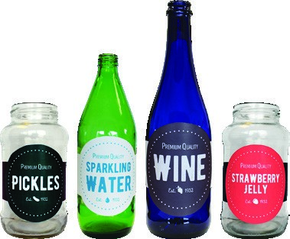
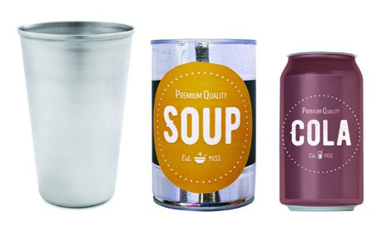
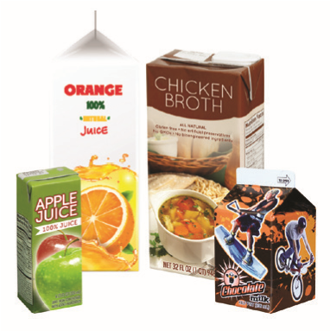
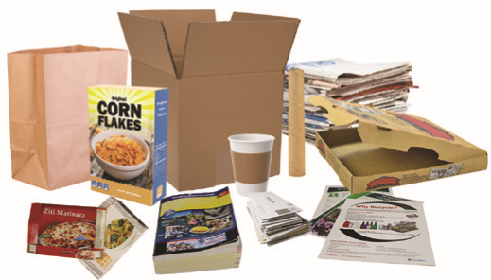
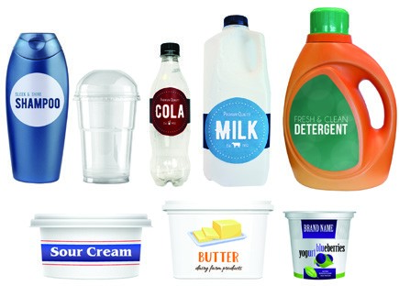
RECYCLING GUIDELINES
Make Your Recycling Count
GLASS BOTTLES & JARS
Any color.
PLEASE

DO NOT BAG

RECYCLABLES
AT DROP BOX SITES
They can be dangerous to Rumpke
employees, damage equipment and
disrupt the recycling program.
METAL CANS
& CUPS
Non-hazardous, non-flammable
material only.
CARTONS
Remove caps and straws.
PAPER
Cardboard should be broken down
to fit inside container.
PLASTIC BOTTLES,
JUGS, TUBS & CUPS
Reattach lid.
Yogurt and fruit cups OK.
IF YOU COLLECT YOUR RECYCLABLES IN A PLASTIC BAG, PLEASE EMPTY THE CONTENTS OF THE BAG INTO THE RECYCLING DROP BOX CONTAINER AND DISPOSE OF THE BAG IN THE TRASH.
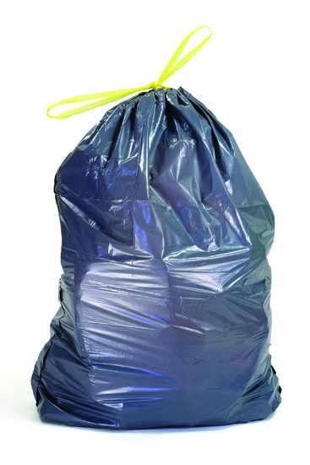
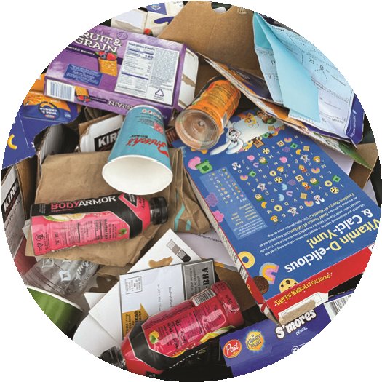
YES!
NO!

ALSO, NO:
- Hoses & Chains  - Batteries  - Clothes & Sheets  - VHS Tapes  - Hazardous Items | - Pressurized Tanks  - Car Parts  - Dishware  - Light Bulbs  - Ropes | - Chemicals  - Electronics  - Needles  - Toys  - Cord & Belts | - Hangers & Wire  - Pots & Pans  - Window Glass
Rumpke Recycling Drop-Box Programs

YOUR RECYCLING LEADER
Rumpke is a recycling leader with innovative facilities across Ohio, Kentucky and Indiana.

RUMPKE PROGRAMS: ADAPTABLE FOR RECYCLING SUCCESS
Rumpke’s drop-box recycling program is simple.
Participants bring their unsorted recyclables to designated drop-off recycling sites, and place them mixed into Rumpke’s container. When full, Rumpke empties the contents of each container into a truck, and replaces the empty container on-site. The mix is taken to a Rumpke facility for sorting

PROGRAM FEATURES
A variety of features and benefits make Rumpke’s program efficient, cost-effective and unique.
- Mobile containers make the program easy to implement and adaptable. Customers can add or relocate containers and drop-box sites to meet current and future needs.
- Adjustable service frequency helps to manage both temporary spikes and long-term growth.
- Collection is fast and material is contained throughout, meaning sites stay well-maintained and pickup causes little interruption.
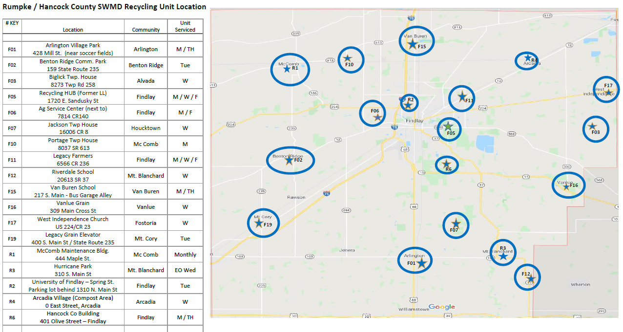
Map Locations as of 8/01/25
This free community recycling opportunity is being provided to you by the Hancock County Solid Waste Management District and the Board of Hancock County Commissioners.
Scan the QR code to get more information and to visit www.HancockEnvironment.com
- Locations and Map of Community Recycling Bins
- Lists of accepted recyclables
- Special Collection Event Details such as HHW-Paint, Paper Shred, Tire etc.
- Education/Presentation Opportunities
- Litter Awareness / Keep America Beautiful / Adopt-A-Road Programs
Contact the Hancock County Solid Waste Management District with questions cares or concerns, HancockSWMD@co.hancock.oh.us or 419-424-7210.
Thanks for Recycling!

